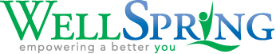

B O T V I N L I F E S K I L L S

Last year, the Ohio Department of Education mandated five social-emotional competency standards in every school in the state. They are 1) self-awareness, 2) self-management, 3) social awareness, 4) relationship skills, and 5) responsible decision-making. Botvin LifeSkills addresses all five.

A research-validated substance abuse prevention program proven to reduce the risks of alcohol, tobacco, drug abuse, and violence by targeting the major social and psychological factors that promote the initiation of substance use and other risky behaviors, this comprehensive program provides students with the confidence and skills necessary to handle challenging situations.

Developed by Dr. Gilbert J. Botvin, a leading prevention expert, Botvin is backed by over 30 scientific studies and is recognized as a Model or Exemplary program by an array of government agencies including the U.S. Department of Education and the Center for Substance Abuse Prevention.

Rather than merely teaching information about the dangers of drug abuse, Botvin LifeSkills Training promotes healthy alternatives to risky behavior through activities designed to:
- Teach students the necessary skills to resist social (peer) pressures to smoke, drink, and use drugs
- Help students to develop greater self-esteem and self-confidence
- Enable students to effectively cope with anxiety
- Increase their knowledge of the immediate consequences of substance abuse
- Enhance cognitive and behavioral competency to reduce and prevent a variety of health risk behaviors

WellSpring is in its fifth year as the lead agency providing Botvin training, materials, data analysis, and onsite support at no cost to schools in Clark county.

Approximately 1,500 students from eleven different schools participated in the Botvin Life Skills Program during the 2019-20 school year. For many the curriculum was interrupted by the coronavirus and cancellation of schools.

The following schools participated in Botvin during the 2020-21 school (Our numbers were impacted by Covid-19) 953 students participated
- GISA (Global Impact STEM Academy) 200 students
- Tecumseh Middle School 193 students
- Greenon Jr High School 42 students
- Ridgewood School 22 students
- Catholic Central 27 students
- New Carlisle Elementary 255 students
- Donnelsville Elementary 214 students

In partnership with the Wittenberg Hagen Center, WellSpring now offers digital pre and post surveys, and customized data analysis reports to every school participating in the curriculum. WellSpring added additional questions to the survey to get perception data from students county-wide.

The Greene County ESC was so impressed to hear of the work done to digitize pre and post surveys, they are now piggybacking onto WellSpring’s partnership with the Hagen Center and providing similar services to the schools in Greene county that are using the Botvin Life Skills curriculum.

Attachments: Individual School Reports, Added Questions Report

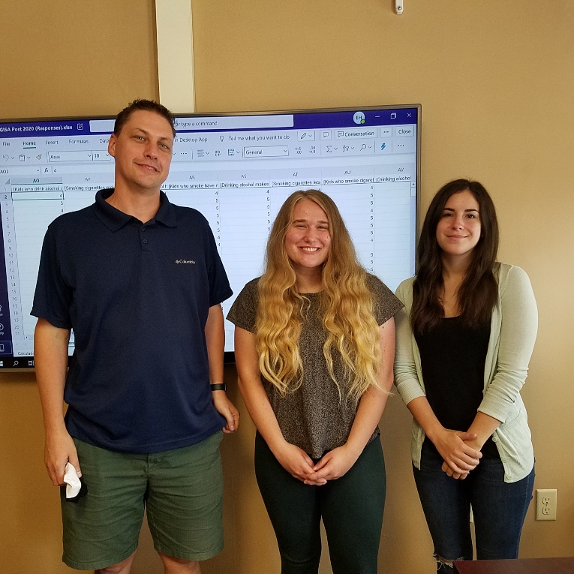

A special thanks to Dr. Ed Hasecke, and our Hagen Center Summer Research Interns (Shelby Smith, center, and Kinsey Obinger, right) for their hard work analyzing Botvin Life Skills school data.

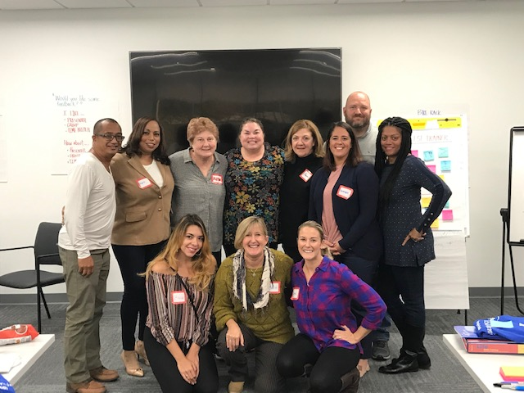

Dawn White and Beth Dixon, among others across the country, are now certified to train teachers, school counselors, prevention specialists, SROs, police officers, community youth educators, and other program providers to effectively implement the state-of-the-art prevention education activities and teaching strategies found in the Botvin Life Skills Program.

It is noteworthy to mention that the Tecumseh School District has fully committed to the Botvin curriculum, offering it now to students in 4th – 8th grade. This will allow us to take a deeper look at the impact of the curriculum on students who receive multiple doses of it.
The following schools are expanding the Botvin Curriculum to additional grades in the 2021-22 school year:
- GISA (currently in the middle school) has been trained to deliver the curriculum to grades 9-12.
- Ridgewood School (currently in grades 6-8) will expand to include grades 3-5.
- New Initiatives: The Clark County Juvenile Court and Shawnee High School are now trained – and will be offering Botvin this fall.

